delete from BeerList

where ABV='5.4'

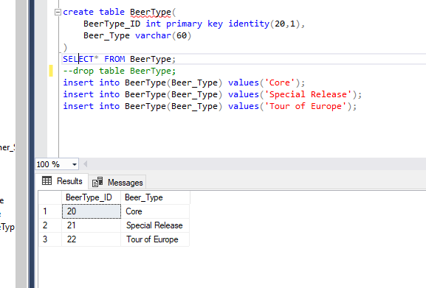

delete from BeerType

where Beer_Type='Tour of Europe';

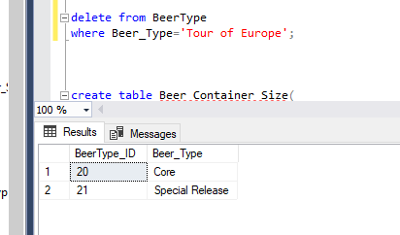

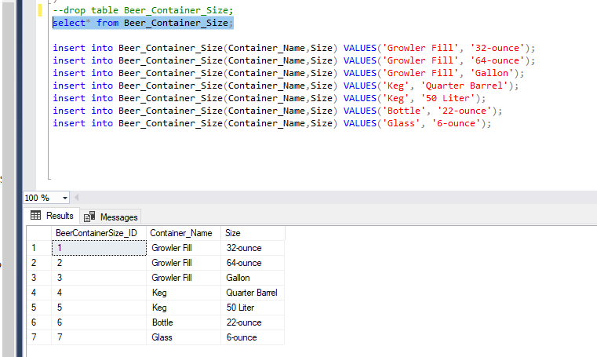

delete from Beer_Container_Size

where Size = '6-ounce';

